Technical Report

Help: Text displayed in blue italics is included to provide guidance to the author and should be hidden before publishing the document. Check/un-check the visibility of hidden text on the screen when editing under Tools>Options>View. Check/un-check the visibility of hidden text when printing the document under Tools>Options>Print.
Summary:
This report presents a statistical analysis of the ramp rates experienced at the PV installation of the ABB Corporate Research Center in Baden-Dättwil.

TABLE OF CONTENTS
1 Introduction 3
1.1 Purpose 3
1.2 Scope 3
1.3 Structure 3
2 PV Installation at chcrc 4
2.1 Plant description 4
2.2 Weather Station 5
3 Data Collection, analyisis and post-Processing 6
3.1 Connection to the Smart Grid Demo Lab Network and Database 6
3.2 Data collection and post-processing 7
3.3 Analysis of irradiation data 9
4 Ramp rate analyis 11
4.1 PV output on clear sky and partly cloudy days 12
4.2 PV output on overcast and cloudy days 12
4.3 Ramp rate experienced in a partly cloudy day (Spring 2011) 13
4.4 Ramp rate experienced in a cloudy day (Summer 2011) 14
4.5 Statistical analysis of ramp rates 15
4.6 Processing of data 16
5 Conclusions 19
6 References 20
Change History 21
Review History 21

Introduction
Help: The introduction should provide an overview of the entire report. It should include the purpose, scope, definitions and structure of this report.

Purpose
Help: Specify the purpose of this report.
The purpose of this report is to provide insights into the level of irradiation intermittency and variability in power generation, experienced both in the area of Baden-Dättwil and in the PV installation of the ABB Corporate Research Centre, and to serve as starting point for further ramp rate control studies. .
The target group for this report is the management of the BU PSPG R&D Product Group Renewables and other relevant members of the product group, including the engineering department of the Power System Division.

Scope
Help: Describe briefly of the scope of this report; what project(s) it is associated with and anything else that is affected or influenced by this report.
The analysis presented in this report is intended to provide input for the design of a Vision based Sky Monitoring (VISMO) system as part of the Cloud Tracking and Solar Forecasting for PV Power Prediction project (Project ID 21174) and also to the Battery Control Project Advanced ESCON (Project ID ????).
.

Structure
This report has the following structure.
Section 1 Introduction (this section) describes the purpose and scope for this report.
Section 2 describes the PV installation currently in operation at the Corporate Research Center.
Section 3 describes the collection, analysis and post-processing of data used in the study.
Section 4 introduces the statistical tools used to analyze the ramp rates.
Section 5 presents the conclusion of this report.

PV Installation at chcrc

Plant description

The PV installation at the Corporate Research Center is located on the roof of building F. It consists of:
- 30 Silicon polycristaline (p-Si) PV modules type Sharp NE-170-U1 forming 3 banks of parallel connected series (10 panels per serie) totaling 5.1 kWp.
- 64 Thin-film Amorphous silicon (a-Si) PV modules type EPV42 Würth CIS-80Wp. forming 6 banks of parallel connected series (8 panels per serie) totaling 5.02 kWp.
Both installations are connected to ABB string inverters PVS300. Two ABB electricity meters with serials with 411664 and 411665 monitor the amount of power produced by installation. The inverters and meters are located in the PV laboratory F105.
A diagram and picture of the installation are shown in Figures 1 and 2.
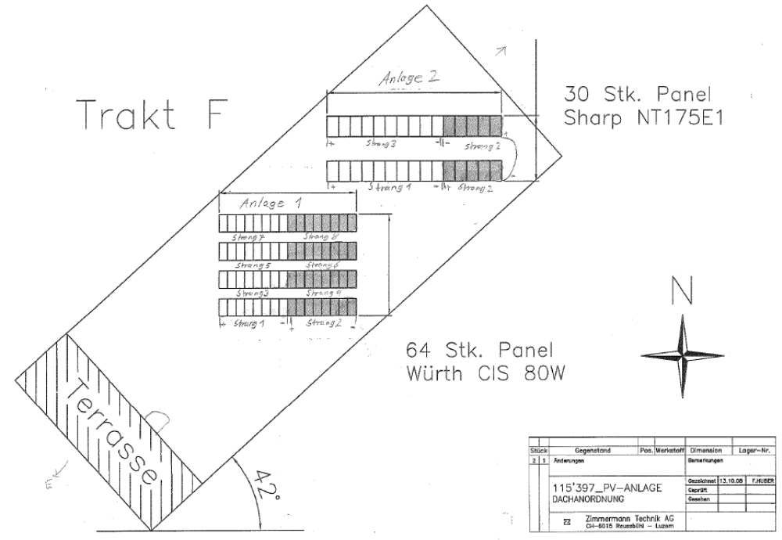

Figure 1. Installation diagram of PV modules mounted on the roof of CHCRC.

.
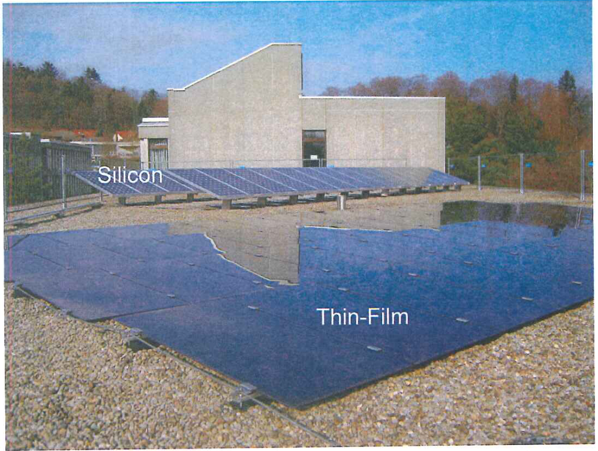
Figure. 2. Picture of the PV installation mounted on the roof of CHCRC

Weather Station

The weather unit and weather sensor WZ/S 1.1 WES/A 2.1, part of the ABB i-bus KNX building automation system [1], were used to collect measurements of irradiation and ambient temperature. The weather unit/sensor WZ/S 1.1/WES/A 2.1 (see Figure 3) are used in residential applications for recording weather data. Additional variables such wind speed, rain, brightness in three directions, twilight, date and time stamp can be obtained from this device.

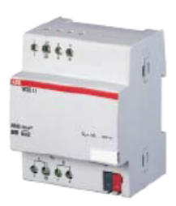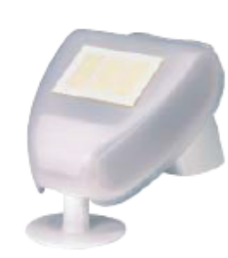
Fig 3. Weather unit and sensor used to collect weather data [2].

Data Collection, analyisis and post-Processing

Connection to the Smart Grid Demo Lab Network and Database

Real-time and historical data for irradiation and PV output were obtained by connecting to the Smart Grid Demo Lab Network [3], [4] and querying the database.
The Smart Grid Demo Lab is an experimental software platform which allows for straightforward control and monitoring of different actuator devices and smart sensors [5] integrated into the KNX building automation system. An overview of the Smart Grid Demo Lab infrastructure is shown in Figure 4.
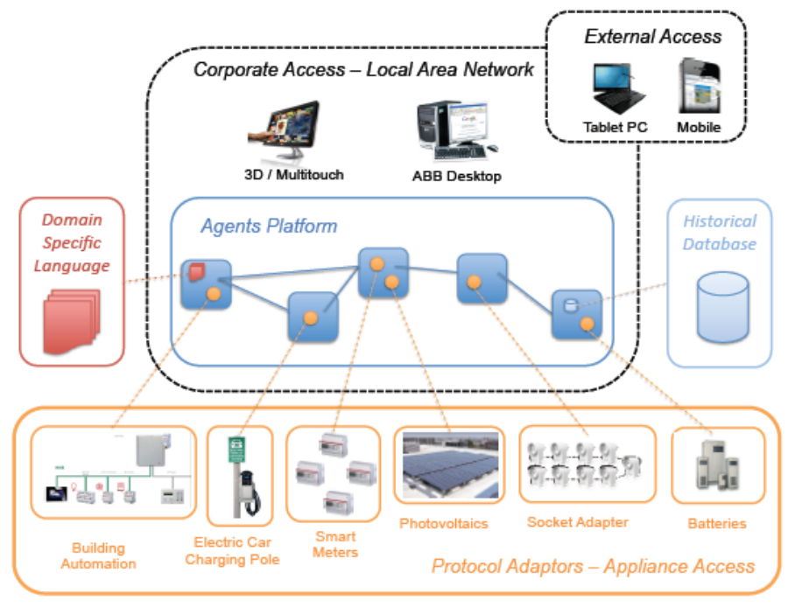
Figure 4. Smart Grid Demo Lab infrastructure [3]

Access to the Smart Grid Database was originally done manually via MySQL workbench software package (ref) where the database was queried and the data exported to a CSV file for analysis. This process was process was slow and cumbersome due to the selection of the data at different time periods and the large amount of data collected. To overcome this manual process, a code was written in MATLAB, using the open source queryMySQL package, to automatically query the database and perform the analysis of the data in one single step, all within the MATLAB environment. This improvement was intended to allow for an automated access of the irradiation and PV output data for the developed cloud tracking system. The code query_KNX_database.m can be found in the appendix of this report.

Data collection and post-processing

Historical measurements of irradiation were obtained from the Smart Grid Demo Lab database connected to the weather unit/sensor. Figure 5 shows the irradiation data from April 2011 to August 2012. This period of time was selected due to the fact that it enclosed measurements from both the pyranometer (irradiation sensor) and the ABB energy meter. Nevertheless, it can be seen that some data were still missing within this period, identified by the gaps shown in Figure 4. This lost in data can be attributed to the disconnection of the Smart Grid network, mainly due to maintenance our fault. Another issue encountered was the fact that irradiation sensor seemed to have been decalibrated after a disconnection which occurred around 28 of July 2011, as shown in Figure 4(a). Another potential explanation for such change in can be attributed to a modification in the configuration of the sensor. After inspection and analysis, an scaling factor was identified which fitted the shape of the data. Figure 4(b) shows the irradiation data after the scaling factor was applied.
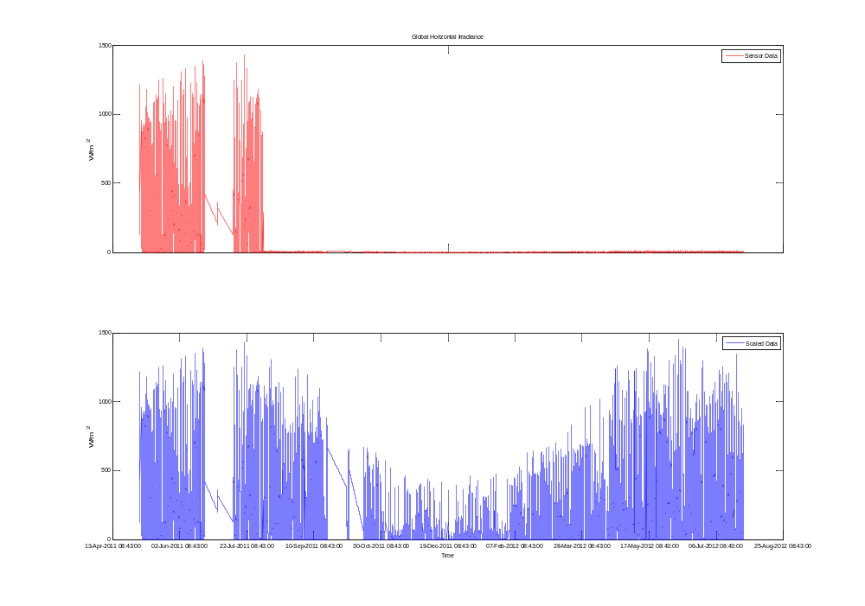
decalibrated/reconfigured sensor after disconnection
(a)
(b)
Figure 5. Irradiation data from April 2011 to August 2012. (a) Raw. (b) Post-processed.
Similarly, historical measurements of PV output were obtained from the Smart Grid Demo Lab database connected to the ABB energy meter. Figure 5 shows the corresponding PV output data for the period April 2011 - August 2012.

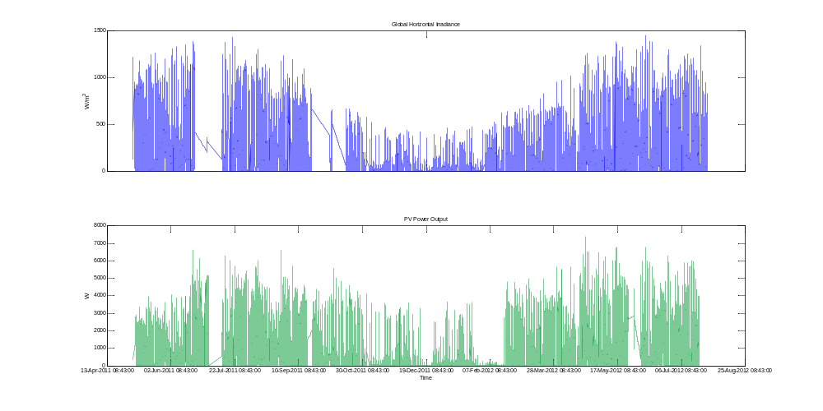
Figure 5. PV output measurements from April 2011 to August 2012

It should be pointed out that both irradiation and PV output data were sampled at different time intervals and the samples times were not consistent throughout the period. For instance irradiation had irregular sampling intervals of 68 and 69 seconds whereas PV output data had irregular sampling intervals of 93, 90 and 87 seconds. Accordingly, the data were regularized to 60 seconds sampling interval by linearly interpolating between measurements. This regularization thus facilitated the calculation of time averages and of statistics the ramp rates presented in the next section.

Analysis of irradiation data

Figure 6 shows the irradiation corresponding to the month of March 2012. In the Figure, the blue lines correspond to actual measurements whereas the red lines represent the clear sky expectation obtained with a clear sky model using information about the geographical location and typical atmospheric factors encountered in Switzerland (ref).
It can be seen that the irradiation level in this moth is quite low reaching < 500 W/m² at peak times in some days. This amount of irradiation is much lower than the one predicted by the clear sky expectation at peak times (1000 W/m²). This indicates that clear sky model overestimates the irradiation for this month probably due to different atmospheric factors utilized fit the parameters of the model. Another explanation can be attributed to the fact that the atmospheric conditions observed in this month did not correspond to typical atmospheric conditions encountered in the past. Unfortunately, due to the lack of historical data this hypothesis could not be verified. Finally, note this month is characterized by few days with low irradiation variability.

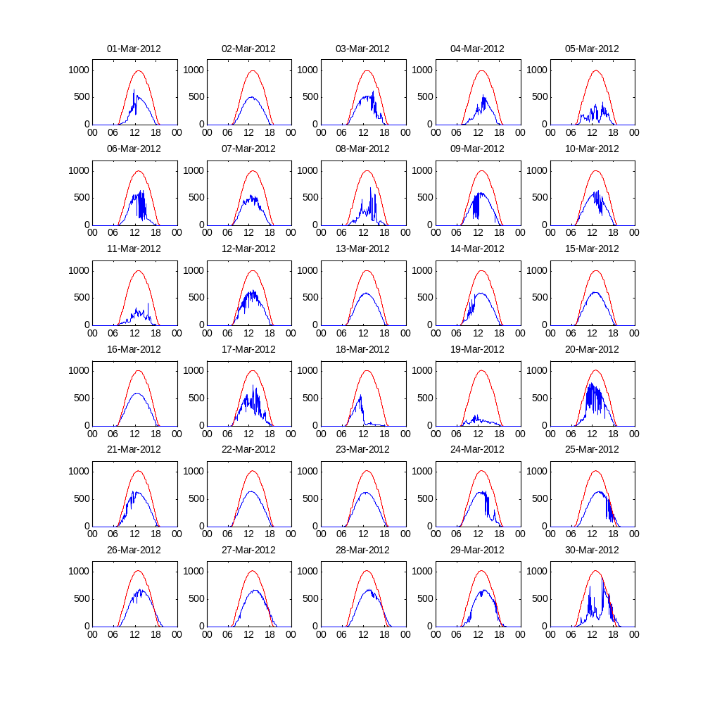
(w/m²)
(w/m²)
(w/m²)
(w/m²)
(w/m²)
(w/m²)
Figure 6. Irradiation measurements corresponding to the month of March 2012

Figure 7 shows the irradiation measurements corresponding to the month of June 2012. It can be observed that in this month, irradiation levels are much higher. This is expected, as this month falls in the summer period where the earth is closer to the sun and thus receives most of the sun irradiation. On the other hand, it can also be observed that most of the days are characterized by high variation in irradiance, with only one day being clear sky (June 16) and the rest being cloudy or overcast (e.g June 2,3 and 6) . Finally note that the clear sky model predicts quite well the levels of irradiance on June 16 and June 22.
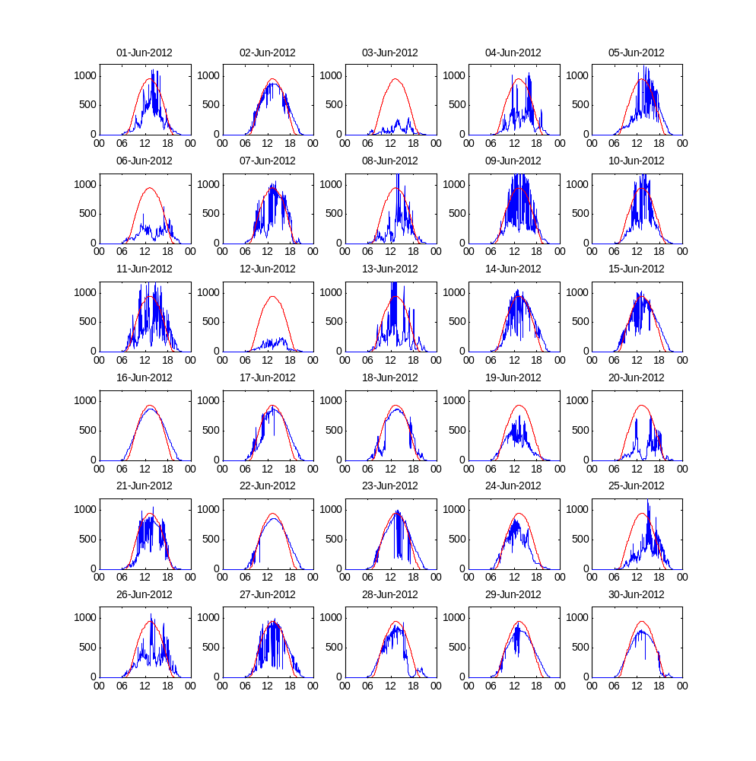
(w/m²)
(w/m²)
(w/m²)
(w/m²)
(w/m²)
(w/m²)
Figure 7. Irradiation measurements corresponding to the month of June 2012

Ramp rate analyis

The result of the analysis presented in this section is based solely on the data collected from the electricity meter 411665. The reason is because, at the time of the execution of this project, only the ABB electricity meter 411665 was operational and connected to the Smart Grid Demo Lab database.

PV output on clear sky and partly cloudy days

Figure 8 shows the irradiation and PV output measurements obtained in clear sky (left hand side) and partly cloudy (right hand side) days. Irradiation measurements are shown at the top whereas PV output measurements are shown at the bottom. It can be observed that a small variation is present on the clear sky day, perhaps due to the presence of thin cirrus clouds. For the partly cloudy day, the variability observed is greater with a steep drop in irradiation around noon, probably due to the presence of a slow moving cloud.

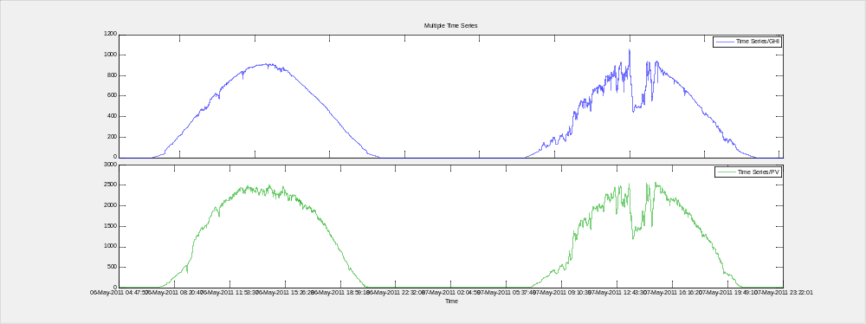
w
w/m²
Figure 8. Irradiation and PV output measurements on clear sky and partly cloudy days

PV output on overcast and cloudy days

Figure 9 shows the irradiation and PV output measurements obtained on overcast (left hand side) and cloudy (right hand side) days. It can be noticed that the irradiation is greatly reduced on a cloud day and so is the PV output. This is, of course, obvious since clouds obstruct the direct normal component of the irradiation leaving only the diffuse component to power the modules. It is interesting to note that in this case, drops in irradiation are not so severe, with the drops probably caused by variation in cloud brightness arising from cloud deformation. In contrast, the drops in irradiation are steep and can occur very frequently throughout on a cloudy day.

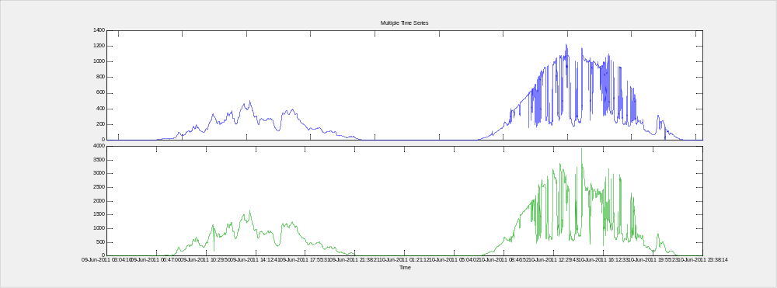
w/m²
w
Figure 9. Irradiation and PV output measurements on overcast and cloudy days

Ramp rate experienced in a partly cloudy day (Spring 2011)

An estimation of the ramp rate experienced in a partly cloudy day was performed by selecting a drop and calculating the rate of decrease in both irradiation and PV output. Since drops in irradiation are equivalent to drops in PV output, and since we are interested only in the rate of change of the latter, only the estimated ramp rate for PV output is presented.
Figure 10 shows an estimated PV output ramp on May 7, 2011. As can be seen, 53% of the power can drop in 14 min in under this condition. This rate of change equates to approximately 15% power loss per min.
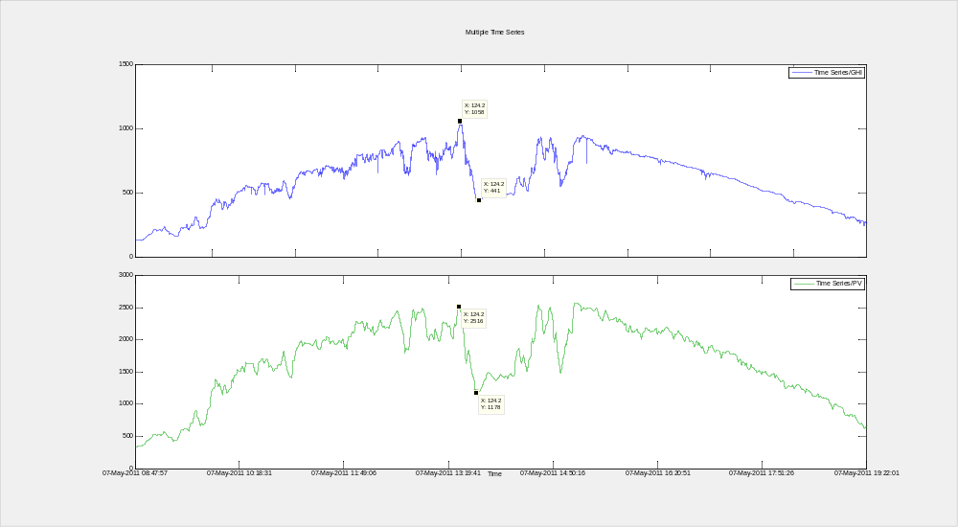
53 % in 14 min
(~4% drop per min)
w/m²
w
Figure 10 Ramp rate experience in a partly cloudy day

Ramp rate experienced in a cloudy day (Summer 2011)

Figure 11 shows an PV output drop estimation on June 17, 2011. In this case, the estimated rate of change is 92 % in 6 min, or equivalently 15% per min.

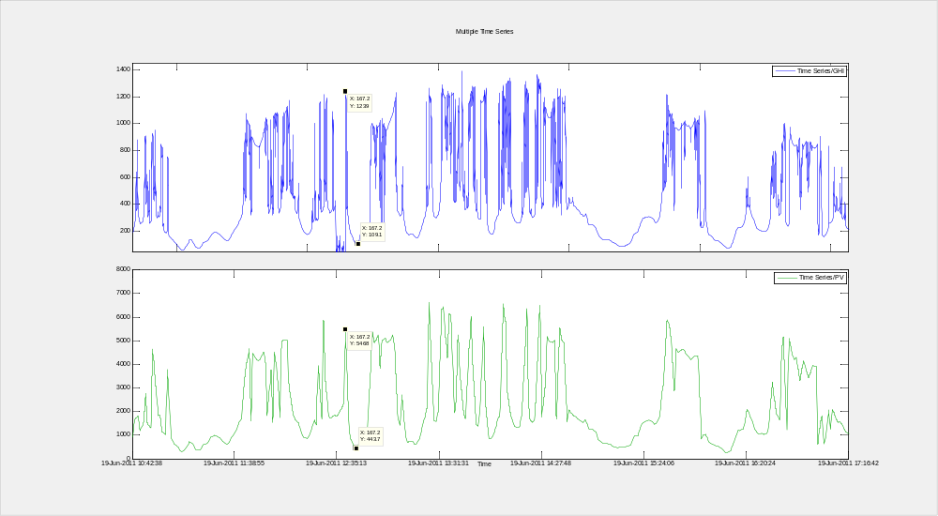
92 % in 6 min
(15% drop/min)
w/m²
w
Figure 11 Typical ramp rate experience in a cloudy day

Statistical analysis of ramp rates

Because visually inspecting for changes in PV output for the complete data set is not practical, a statistical analysis is often employed to analyze PV output variability.
PV output variability is characterized by changes in magnitude of the generated power over a specified of time (e.g. kW/min) and is estimated by differencing consecutive power values:
$$∆P\left(t\right)=P\left(t\right)-P(t-1)$$
and dividing by time interval length :
$$∆P\left(t\right)=\frac{P\left(t\right)-P(t-1)}{∆t}$$
A time series of ramp rates can be used to compare intermittency in generation using different time intervals. As shown earlier, the time series of ramp rates is represented by the slop of the line segments connecting consecutive power values.
Various statistics can be used to analyze the distribution ramp rates. Simple statistics such as mean and standard deviations can provide insights into the distribution of the ramps, nevertheless a more intuitive way to illustrate the degree of variability is use distribution statistics or probabilities including:
- k3$σ$: the likelihood of extreme events compared to a normal distribution
- the probability of not exceeding a ramp rate threshold or
- the maximum step change for a given probability.
In the following we present the analysis using the both the probability of not exceeding a ramp rate threshold and maximum step change for a given probability.

Processing of data
The collected data were further processed using a module approach summarized in the flowchart shown in Figure 12.

Raw Plant Output Data from Database
Change empty cells to 'NaNa'
Change power output sign
Select daytime period
Discard incomplete days
Regularize data uniform sampling
Divide data into months and days
Pre-Processing
Structuring
Data Analysis
Select interval length
Calculate ramp rate
Display Histograms and CDF plots

Discard incomplete days

Figure 12 Flow diagram of the procedure used to compute and analyze ramp rates

The data were checked for consistency and completeness. Due to the fact that the data were taken at different sampling intervals the data were regularized using a uniform sampling interval. In addition, data corresponding of night times (i.e. 7 pm to 9 am) were excluded from the analysis. Using the processed data, cumulative distribution functions and histograms of ramp rates were computed at different time intervals.

To highlight the importance of working with high resolution data and illustrate the implications of using data sampled at coarser time scales (this is a very common problem of data loggers), time series of ramp rates were computed using 1, 10 and 60-min averaged power time series. Since the resolution of the data is 1 min, not averaging took place in the first case. The two latter cases occur when for example power output measurements are taken every minute or every second and reported as 10 or 60 minute averages.

Figure 12 shows the distribution of the ramps using 1, 10 and 60 min minute time intervals. Also shown in the Figure are fitted normal distribution functions. From the figure, it can be observed that the distribution of the ramps is not normal, as the frequency of extremes ramps exceed the frequency given by the normal distribution and the distribution is heavy tailed. It can also be noticed that the ramp rates obtained with averaged time series results in the distributions being narrower indicating a reduction in the variability. The reduction in variability results because the power values used to compute the ramp rates are averages and therefore the computed ramp rates will cluster around their mean (as proved by the central limit theorem) . Accordingly, estimating ramp rates with data sampled at a coarse resolution will have the effect of heavily underestimating variability and masking the frequency of the (extremes) ramps .
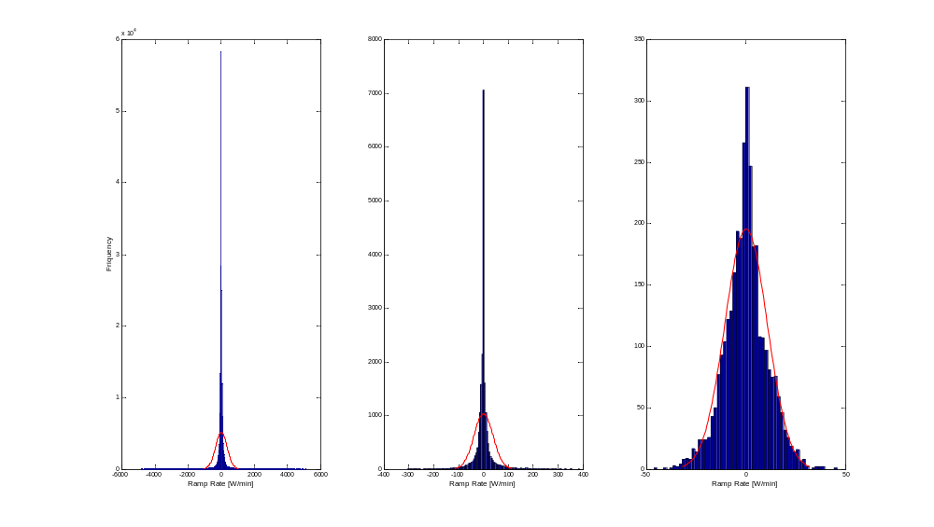
Figure 12 Distribution of ramp rates at 1, 10 and 60 min averaged time intervals

The same conclusion can be drawn by looking at the cumulative distribution function of the ramps, as shown in Figure 13. Moreover, Figure 13 shows that drops computed using short average times (e.g. 1-min) can be steep. It fact, using the plot below one can estimate the probability of a given ramp occurring. For instance, the probability of power drop of less than 1000 W/min occurring is 98%.
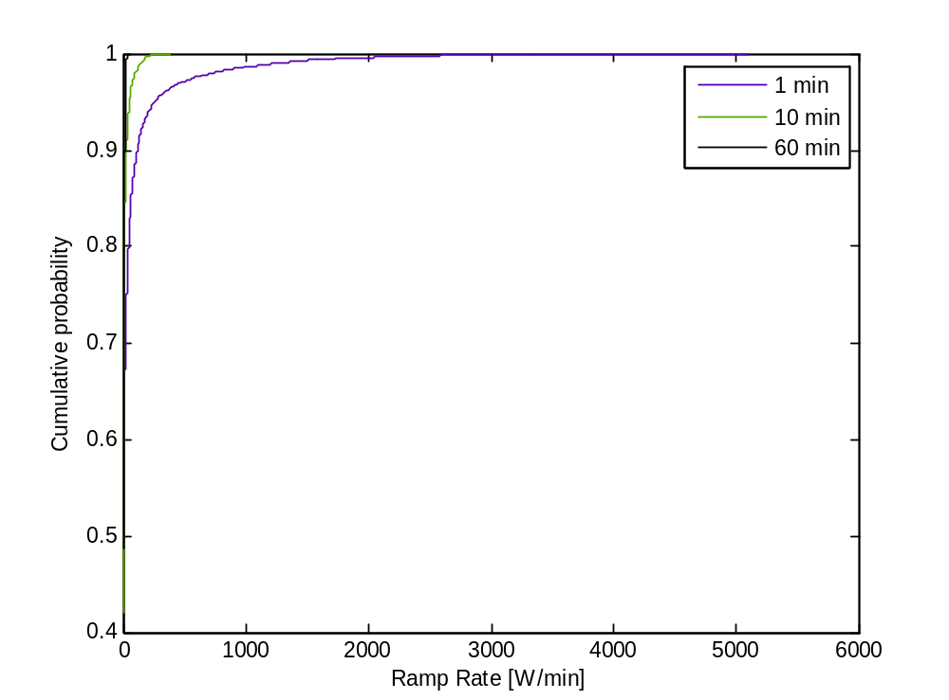
98 % of all step changes are smaller than 1000 W/min
Figure 13 Cumulative probabilities of ramp rates at 1, 10 and 60 min averaged time intervals. Probability of not exceeding a certain threshold

Likewise, one can estimate the maximum step change for a given probability, as shown in Figure 14. For instance, for a probability of 90 % the maximum step change is 100 W/min. This can also be interpreted as 10 % of all step changes are greater than 100 W/min.

90 % of all step changes are smaller than 106 W/min
Figure 13 Cumulative probabilities of ramp rates at 1, 10 and 60 min averaged time intervals. Maximum step change for a given probability

Conclusions
Studying the ramps experienced by a PV grid-connected PV installation is important as they can affect the voltages and frequency of the power transmitted through grid. To guaranty continuity of the supply and efficient operation, grid operators must keep the system voltage and frequency within specified tolerances. A step towards achieving this objective is to quantify and evaluate the effects of PV output variability in order to derive appropriate control strategies which can mitigate such effects. In this regard, knowledge of the frequency and magnitude of extreme ramps is crucial.
In this report a statistical analysis of the ramp rates experienced at the PV installation of ABB Corporate Research has been presented. It was shown that the generation is highly variable with extreme events (> 1000 W/min) occurring 2% of the time (as estimated within a year of data). These extreme events occur, as expected, mostly in summer where the generation is high due to high global irradiation and intermittent due to the relatively fast movement of clouds (characteristic of cloudy days). Finally, to illustrate the effects of using data at coarse resolution, ramp rates were computed using averaged values of power at different intervals. It was shown that time averaging has the effect of underestimating the variability of the computed ramps and masking the occurrence of extreme ones. This thus highlights the need to select the appropriate time scale for collecting and analyzing weather and PV data when tackling ramp rate control studies.

References

[1] “ABB i-bus ® KNX Intelligent Installation Systems: System description.” ABB AG, 2013.
[2] “ABB i-bus ® KNX Weather Unit / Weather Sensor: Product Manual.” ABB AG, 2010.
[3] D. Adolf, “SmartScript: A Domain-Specific Language for Appliance Control in Smart Grids,” Master Thesis, Power Systems Laboratory, ETH Zürich, 2011.
[4] Der-Yeuan Yu, “Smart Office: Building Automation with Multi-Agent Systems.” ABB Technical Report, Software Technologies, Department of Automation, 2012.
[5] “ABB i-bus ® KNX Smart Home and Intelligent Building Control: Product Range Overview 2013.” ABB AG, 2013.

Change History

Rev. | Chapter | Description | Date / Dep. / Name
01 | All | Initial document | 13-11-13/CHCRC.C1 / Luis Dominguez

Review History

Rev. | Chapter | Reviewer(s) | Date
01 | All | M. Mercangöz /CHCRC.C1 | 13-11-14

